|  |  |  |
| --- | --- | --- |
| **ALPHA**  **UNIVERSITY** |  | **LINCOLN**  **UNIVERSITY** |

**Topic: Leadership and team building**

**Name: Abdirahmaan abdikaadir mouse**

**Master of business administration**

**Course: Human resource management**

**Lecturer: Marjan usama**

**Student ID: 16**

**Submission date: 30/ may/2025**

**Contents**

**1. Introduction** 3

**Objectives of the Study: Leadership and Team Building** 3

**Significance of the Study: Leadership and Team Building** 3

**2. Understanding Leadership** 4

**Some of the key characteristics of effective leaders are:** 4

**3. Importance of Leadership in a Company** 5

**4. Leadership Types:** 5

**5. Leadership Theories and Styles** 6

**6. Differences of leadership and management** 7

**7.** **Team Building Essentials** 8

**Tuckman's Team Development Model** 9

**8. Importance of Team Building in a Company** 9

**9. Leadership's Role in Team Building** 10

**Leadership Behaviors that Facilitate Team Effectiveness** 11

**10. Effective Communication in Teams** 11

**Types of Communication** 11

**11. Leadership and Team Building Challenges** 12

**Solutions** 12

**12. Case Studies and Examples** 12

**13. Conclusion** 13

**14. References** 14

# **1. Introduction**

Leadership and team building are essential components of successful organizations in any sector. Leadership provides vision, direction, and inspiration, and team building fosters cooperation, trust, and synergy between team members. With organizations competing in a globalized and fast-paced world, successful leadership and team building are more essential than ever. This essay discusses the practices, theories, and challenges of team building and leadership. Drawing on scholarly research, case studies, and practical examples, it is an exhaustive examination of how leaders can develop high-performing teams to perform business successfully.

## **Objectives of the Study: Leadership and Team Building**

* To Understand the Concept of Leadership
* To Examine Leadership Theories and Styles
* To Explore the Fundamentals of Team Building
* To Assess the Role of Leadership in Team Building
* To Assess Communication's Role in Effective Teams
* To Determine Leadership and Team Building Challenges
* To Illustrate Concepts through Real-Life Examples and Case Studies
* To Highlight Best Practices for Building High-Performing Teams
* To Promote Ethical and Inclusive Leadership
* To Contribute to Professional and Organizational Development

## **Significance of the Study: Leadership and Team Building**

* Enhances Organizational Performance
* Enhances Employee Engagement and Morale
* Enables Successful Change Management
* Encourages Collaboration and Innovation
* Develops Future Leaders
* Informs Human Resource Strategies
* Addresses Cross-Cultural and Global Challenges
* Enhances Conflict Resolution and Workplace Harmony
* Enriches Crisis Management Capability
* Contributes to Academic Literature and Practical Knowledge

# **2. Understanding Leadership**

Leadership is a process of inspiring others to achieve common goals. It involves setting direction, aligning people, inspiring and motivating them, and creating change (Kotter, 1996). Leadership is vision, innovation, and flexibility, whereas management is order and consistency. A good leader is both a strategist and a coach who values team dynamics and optimizes individual strengths.

Leadership is the process of influencing others to see and consent what is to be done and how it is to be done, and the avenues of helping individual and group efforts towards a common goal (Yukl, 2013). Leaders play an instrumental role in setting direction, creating a vision that inspires, and creating an atmosphere that encourages innovation and productivity.

Leadership is a role of influencing, guiding, or directing groups or individuals to a common objective. It is an issue of setting a vision, motivating others, decision-making, and having an environment where people can work and collaborate well.

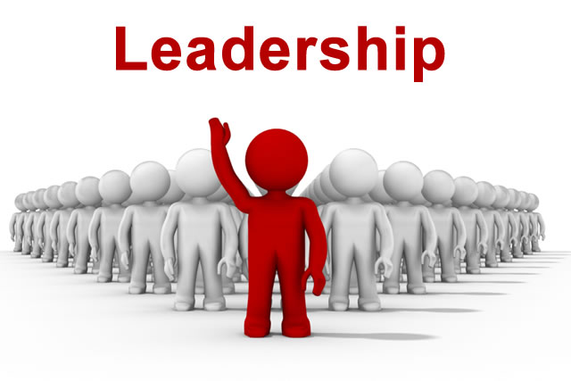

## **Some of the key characteristics of effective leaders are:**

* Vision and strategic thinking
* Emotional intelligence (Goleman, 1995)
* Decision-making ability
* Interpersonal and communication skills
* Honesty and ethics

# **3. Importance of Leadership in a Company**

Leadership plays a vital role in the success and growth of any company. Effective leadership influences every aspect of an organization—from employee motivation to long-term vision and strategy.

|  |  |
| --- | --- |
| **Area** | **How Leadership Helps** |
| **1. Vision and Direction** | Leaders set a clear vision and strategic goals, guiding the company toward long-term success. |
| **2. Employee Motivation** | Strong leaders inspire and motivate employees, increasing engagement and job satisfaction. |
| **3. Decision-Making** | Good leadership ensures timely and wise decisions, especially during crises or uncertainty. |
| **4. Teamwork and Culture** | Leadership promotes collaboration, trust, and a positive workplace culture. |
| **5. Change Management** | Leaders guide the company through changes (e.g., new systems, structures, or markets). |
| **6. Productivity** | By aligning employees with goals and reducing confusion, leaders help boost overall performance. |
| **7. Talent Development** | Leaders mentor and develop future leaders, ensuring sustainability and growth. |
| **8. Reputation** | A company with strong leadership earns respect from clients, investors, and the public. |

# **4. Leadership Types:**

There are many leadership styles. Some leaders are authoritarian and directive, while others are democratic and participatory. What works best will depend on the situation.

For instance, a warfare commander may need to exercise autocratic leadership during combat, while a CEO of a tech startup may discover that she requires a transformational style in order to foster innovation and creativity. Good leadership is evidenced by one's ability to change the leadership style to fit the situation and the people.

|  |  |  |
| --- | --- | --- |
| **Leadership Style** | **Description** | **Best For** |
| **1. Autocratic** | The leader makes decisions alone without input from others. | Quick decisions, crisis situations |
| **2. Democratic (Participative)** | The leader includes team members in decision-making. | Building trust, teamwork, and innovation |
| **3. Transformational** | Inspires and motivates followers to exceed expectations and embrace change. | Driving innovation, organizational change |
| **4. Transactional** | Focuses on clear tasks, rewards, and punishments. | Routine tasks, structured environments |
| **5. Servant Leadership** | Puts the needs of the team before the leader's own interests. | Non-profits, organizations focused on people |
| **6. Laissez-Faire** | Offers minimal direction; team members make their own decisions. | Highly skilled, independent teams |
| **7. Charismatic** | Relies on the charm and personality of the leader to inspire others. | Short-term motivation, crisis leadership |
| **8. Situational** | Adapts leadership style based on the situation or team’s needs. | Dynamic, fast-changing environments |

# **5. Leadership Theories and Styles**

Understanding leadership theories helps in determining efficient leadership behavior and techniques. A few of the most significant leadership theories and styles are elaborated upon below:

* **Trait Theory**

It suggests that leaders are born with some fundamental characteristics such as self-assurance, intelligence, and charisma. Although influential, it has been criticized since it does not account for situational forces (Northouse, 2021).

* **Behavioral Theory**

It focuses on what a leader does, and not who a leader is. The two task-oriented and people-oriented behaviors are the two, and effective leadership is a combination of the two.

* **Contingency Theory**

From Fiedler, this theory holds that leadership effectiveness is a situational factor. Leaders must adapt their style to meet the requirements of the situation.

* **Transformational Leadership**

Transformational leadership inspires and encourages followers to do more than is expected through an emphasis on vision, values, and intellectual stimulation (Bass & Riggio, 2006).

* **Transactional Leadership**

Transactional leaders care about structure, rewards, and punishments to achieve goals. Successful in mundane operations, it has the ability to stifle innovation.

* **Servant Leadership**

This paradigm cares about serving first, making it possible for others to contribute, and creating community within the organization (Greenleaf, 1977).

Example: Satya Nadella, CEO of Microsoft, transformed company culture through promoting a growth mindset and culture of learning and empathy.

# **6. Differences of leadership and management**

|  |  |  |
| --- | --- | --- |
| **Aspect** | **Leadership** | **Management** |
| **Definition** | The ability to influence, inspire, and guide others toward a vision or goal | The process of planning, organizing, and coordinating resources to achieve objectives |
| **Focus** | People and vision | Processes and systems |
| **Key Function** | Motivating and inspiring change | Controlling and directing to maintain stability |
| **Approach** | Visionary and strategic | Administrative and tactical |
| **Primary Goal** | Driving innovation and change | Achieving organizational efficiency and effectiveness |
| **Decision-Making** | Often intuitive and based on long-term vision | Often analytical and based on short-term goals |
| **Style** | Influential and charismatic | Authoritative and procedural |
| **Risk Tolerance** | More open to risk and experimentation | Risk-averse, prefers predictability |
| **People Orientation** | Builds relationships and trust | Manages tasks and processes |

# **7.** **Team Building Essentials**

Team building is the process of transforming a team of individual contributors into a cohesive team working toward shared goals. Effective team building leads to increased productivity, employee engagement, and organizational performance.

Team building is a process for developing an efficient group of human beings who together work and cooperate to achieve shared goals through strengthening communication, trust, and cooperation among individuals.

Team building is a series of activities or methods designed to foster better social relationships and build roles within teams that generally contribute towards enhancing team performance, problem-solving, and teamwork in the workplace.

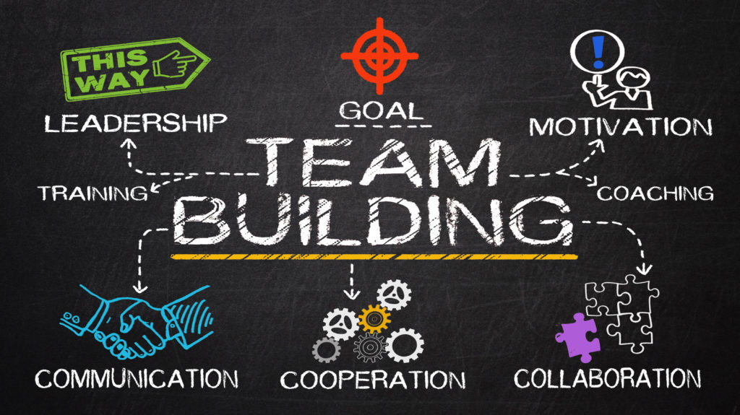

## **Tuckman's Team Development Model**

* Forming: Team members are assembled, and roles have not yet been defined.
* Storming: There can be conflict as people express their opinions.
* Norming: Group cohesion is stronger, and norms are established.
* Performing: Effective team work towards objectives.
* Adjourning: Team breaks up once objectives have been achieved.

**Most Important Ingredients of High-Performing Teams**

* Clear goals and shared vision
* Roles and responsibilities clearly defined
* Open communication and feedback
* Trust and respect for one another
* Effective mechanisms for conflict resolution

Example: Spotify's development teams employ agile squads that enable autonomy, accountability, and alignment, permitting fast innovation and problem-solving collaboration.

# **8. Importance of Team Building in a Company**

Team building is essential for creating a productive, motivated, and cooperative workforce. It strengthens relationships, boosts morale, and aligns team members toward shared goals.

|  |  |
| --- | --- |
| **Area** | **How Team Building Helps** |
| **1. Improves Communication** | Encourages open dialogue and understanding among team members. |
| **2. Builds Trust** | Fosters trust and respect, making it easier to work together and solve problems. |
| **3. Enhances Collaboration** | Promotes a collaborative mindset instead of competition or isolation. |
| **4. Increases Productivity** | Better teamwork leads to more efficient and effective work processes. |
| **5. Boosts Morale** | Fun and engaging activities can reduce stress and improve employee satisfaction. |
| **6. Encourages Creativity** | Safe team environments help employees share ideas more freely and innovate. |
| **7. Strengthens Team Roles** | Helps individuals understand their roles and how they contribute to the team’s success. |
| **8. Conflict Resolution** | Helps prevent or resolve misunderstandings through stronger interpersonal relationships. |
| **9. Employee Retention** | Teams with strong bonds are more likely to stay and grow with the company. |
| **10. Alignment with Goals** | Reinforces company values and ensures all team members are working toward common objectives. |

# **9. Leadership's Role in Team Building**

Team building and leadership are inseparable. Leaders play a key role in:

* Setting a vision: Clearly communicating goals for the team.
* Creating a positive culture: Developing inclusivity, trust, and psychological safety (Edmondson, 1999).
* Encouraging collaboration: Breaking down silos and promoting teamwork.
* Monitoring progress: Providing feedback and facilitating course correction.

## **Leadership Behaviors that Facilitate Team Effectiveness**

* Modeling behavior desired
* Celebrating team success
* Providing professional development opportunities
* Balancing diversity and cohesion of the team

Example: The successes of NASA's Mars Rover missions depended upon sound leadership that encouraged cross-disciplinary collaboration among engineers, scientists, and operations personnel.

**Case Study**: Southwest Airlines has cultivated a culture where team members are empowered, rewarded, and encouraged to offer suggestions. Leadership is instrumental in keeping the culture healthy.

# **10. Effective Communication in Teams**

Communication is the bloodstream of high-performing teams. Leaders must ensure that team members know their role, the team's goals, and where their work belongs in the larger scheme of things.

## **Types of Communication**

* Verbal (briefings, meetings)
* Non-verbal (tone, body language)
* Written (reports, emails)
* Digital (collaborative tools, instant messaging)

**Strategies for Effective Team Communication**

* Establish regular communication channels (e.g., daily stand-ups)
* Use active listening and feedback
* Use collaborative tools (e.g., Trello, Slack)
* Develop transparency and information sharing

Example: Use of Confluence and Jira by Atlas Sian promotes open documentation and structured task management in geographically dispersed teams.

# **11. Leadership and Team Building Challenges**

Despite best intentions, leaders and teams typically face a series of challenges:

* Cultural diversity: Confusion arising from differences in values and communication styles.
* Remote work: Difficulty in building rapport and maintaining accountability.
* Conflict: Personalities can clash, creating tension.
* Resistance to change: Members may resist new leadership styles or technologies.

## **Solutions**

* Offer cultural competency training
* Clarify expectations and deliverables
* Offer conflict resolution through mediation
* Facilitate change through inclusive planning and small wins

**Case Study:** IBM transitioned to a remote workforce and addressed communications and accountability challenges by harnessing leadership development and digital transformation.

# **12. Case Studies and Examples**

**Google's Project Aristotle**

Google conducted an in-house study to determine what makes effective teams. The most critical one was psychological safety, where the members feel safe to take risks and be vulnerable in front of the others. Teams high in psychological safety were more innovative and productive.

**Zappos**

Under CEO Tony Hsieh, Zappos emphasized a culture of employee happiness and strong team values. Self-management and transparency were encouraged by leadership, resulting in high employee satisfaction and customer service excellence.

**Military Leadership: U.S. Navy SEALs**

Leadership and team building are at the core of the Navy Seals’ success. Leadership is adaptive and distributed, and all members are trained to lead. Trust, shared values, and rigorous training are key components.

# **13. Conclusion**

Leadership and team building are the heart of effective modern organizations. Leadership provides vision, direction, and purpose, while team building ensures individuals function together at their best in order to achieve shared objectives. By understanding and applying leadership theory, building effective team dynamics, and reducing common pitfalls, organizations create solid, innovative, and high-performing teams. The integration of effective communication, trust, and strategic leadership gives birth to a culture where teams thrive and organizations excel.

Leadership and team building are the pillars to organizational success. Throughout this study, it has been demonstrated that leadership is far more than giving direction, but motivating, empowering, and guiding people towards the shared vision. Leadership approaches such as transformational, servant, and transactional play various roles depending on the situation, yet all of them stress the importance of vision, ethics, communication, and flexibility.

Team building, on the other hand, entails the formation of effective teams that function in a harmonious and cohesive manner. Tuckman's team development model, among others, sets that teams develop in stages, each requiring differing leadership interventions. High-performance teams are characterized by trust, respect, vision, and well-defined roles. Leadership plays a significant part in shaping how teams are formed, how they function, and how they can be overcome.

Communication keeps teams together. Leaders must build cultures where open discussion, feedback, and psychological safety are appreciated. The convergence of technologies has also altered how teams collaborate with each other, especially in virtual or global settings.

Challenges such as team conflict, change resistance, and cultural diversity cannot be avoided. But with strategic leadership, the right training, and integration, the impediments may be transformed into strengths. Examples of companies such as Google, Zappos, and institutions such as the U.S. Navy SEALs illustrate the true strengths of positive leadership and team cohesion.

# **14. References**

Bass, B. M., & Riggio, R. E. (2006). Transformational leadership (2nd ed.). Lawrence Erlbaum Associates.

Edmondson, A. C. (1999). Psychological safety and learning behavior in work teams. Administrative Science Quarterly, 44(2), 350–383.

Goleman, D. (1995). Emotional intelligence: Why it can matter more than IQ. Bantam.

Greenleaf, R. K. (1977). Servant leadership: A journey into the nature of legitimate power and greatness. Paulist Press.

Kotter, J. P. (1996). Leading change. Harvard Business Review Press.

Northouse, P. G. (2021). Leadership: Theory and practice (9th ed.). Sage Publications.